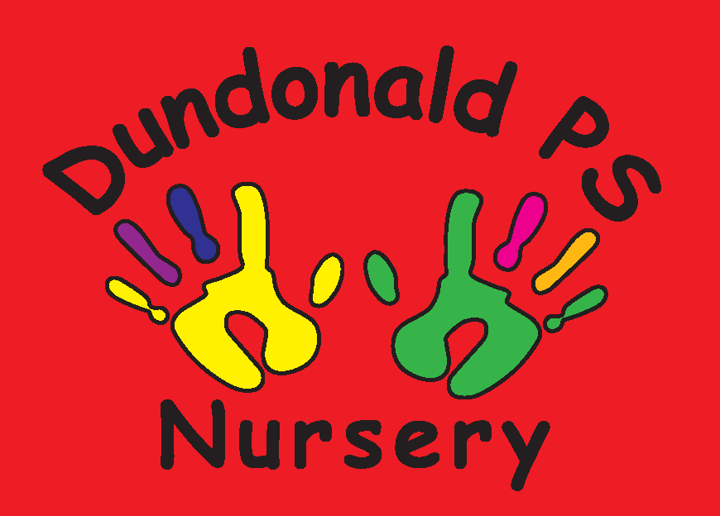
Dundonald Nursery February Songs & Rhymes


I love You

I love you
you love me
we're a happy family
with a great big hug and a kiss from me to you
wont you say you love me too!


I love you, you love me
we're best friends as friends should be
with a great big hug and a kiss from me to you
wont you say you love me too!


You are my sunshine
You are my sunshine, my only sunshine
You make me happy when skies are grey
You'll never know dear, how much I love you
Please don't take my sunshine away

Spanish weather – ¿Qué tiempo hace?
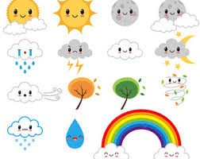
Sol y nubes sol viento lluvia nubes

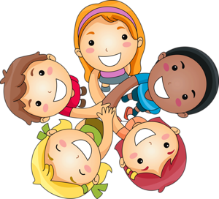
My Friend is Different and So Am I

My friend is different and so am I,
So am I, so am I.
My friend is different and so am I,
We like to play together.

...we like to sing together.
... we like to dance together.
... we like to help each other.

(Sung to the tune of London Bridge is falling down.)

Look What We Can Do!

Lips whistle, heads think
I’m clever, so are you
Look what we can do!
Arms cuddle, legs walk,
Thumbs wiggle, mouths talk
I’m clever, so are you
Look what we can do!

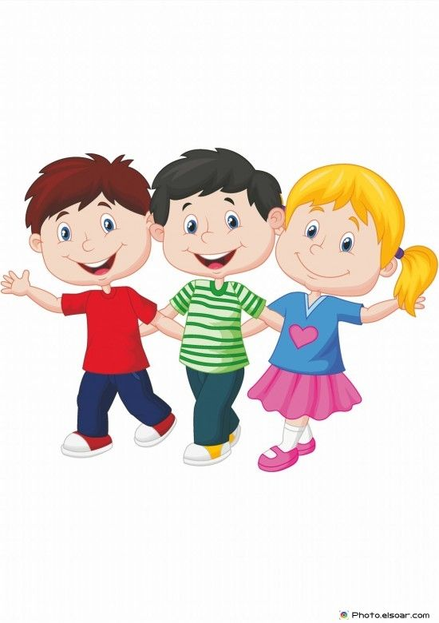
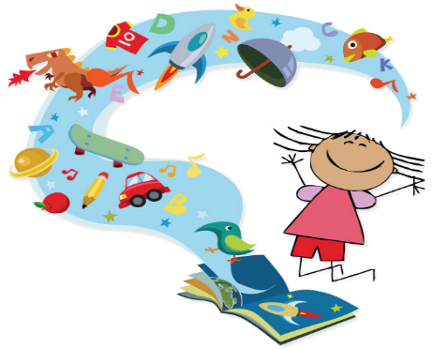
Everyone Who You Can See Is Special Too
I am not the same as you, you are not the same as me everyone who you can see is different too. (x2)
Some are short, some are tall, some have got no hair at all. Some are fat, some are thin, some have different coloured skin.
I am not the same as you, you are not the same as me everyone who you can see is special too. (x2)

