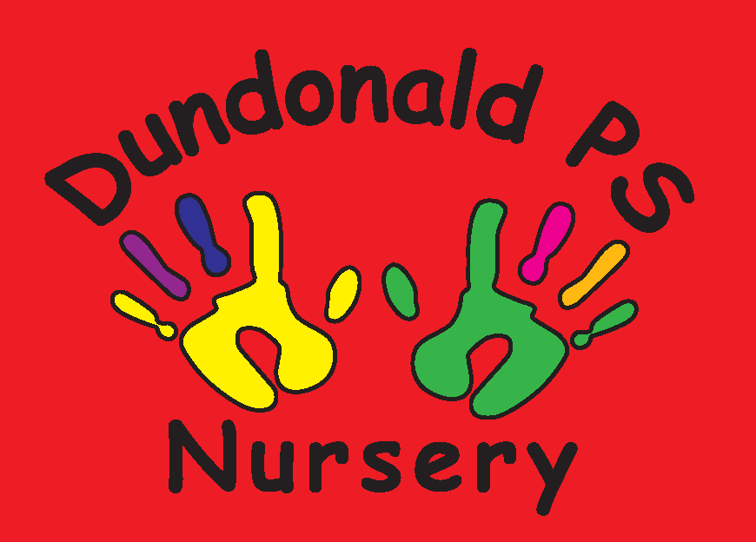
Dundonald Nursery January Songs & Rhymes
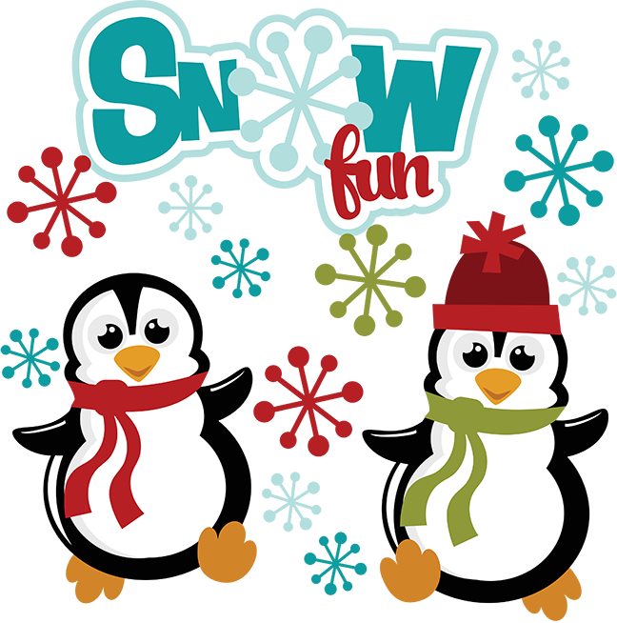

I'm a Little Penguin
I'm a little penguin
Black and white.
Stout and fluffy
What a sight!
I can't fly
but I love to swim.
So I'll waddle to the water
and dive right in!
(Tune of ‘I'm a Little Teapot’)

Put your coat on
Put your coat on, put your coat on
And make yourself nice and cosy.
Put your coat on, put your coat on,
And come along out to play.

Put your hat on, put your hat on,
And make your head nice and cosy.
Put your hat on, put your hat on
And come along out to play.

Put your scarf on, put your scarf on,
And make your neck nice and cosy.
Put your scarf on, put your scarf on,
And come along out to play.

(continue with boots/feet and gloves/hands)

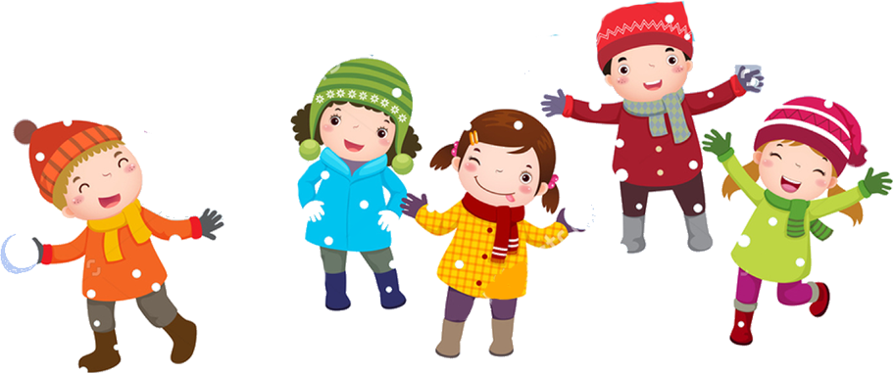

5 Hungry Penguins
(tune of 10 green bottles)

5 hungry penguins standing by the sea
5 hungry penguins standing by the sea
And if 1 hungry penguin should catch a fish for tea
There’ll be 4 hungry penguins standing by the sea

4 hungry penguins standing by the sea...
3 hungry penguins standing by the sea...
2 hungry penguins standing by the sea...
1 hungry penguin standing by the sea...

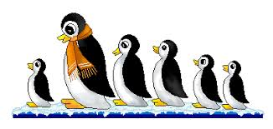

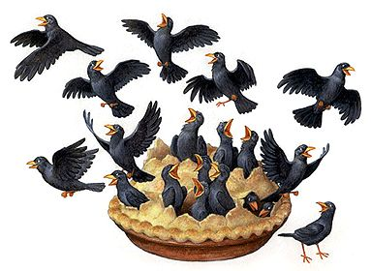
Sing a Song of Sixpence
Sing a song of sixpence a pocket full of rye,
Four and twenty blackbirds baked in a pie.
When the pie was opened the birds began to sing,
“Oh wasn't that a dainty dish to set before the king?”
The king was in his counting house counting out his money,
The queen was in the parlour eating bread and honey
The maid was in the garden hanging out the clothes,
When down came a blackbird and pecked off her nose!

Winter Mittens
If you’re wearing red mittens, clap your hands.
If you’re wearing red mittens, clap your hands.
If you’re wearing red mittens, red, red mittens.
If you’re wearing red mittens, clap your hands.

If you’re wearing blue mittens, stomp your feet...
If you’re wearing yellow mittens, shake your head...
If you’re wearing green mittens, bend your knees...
If you’re wearing orange mittens, tap your nose...
If you’re wearing purple mittens, touch your toes...

(Tune of ‘If you’re happy & you know it’)

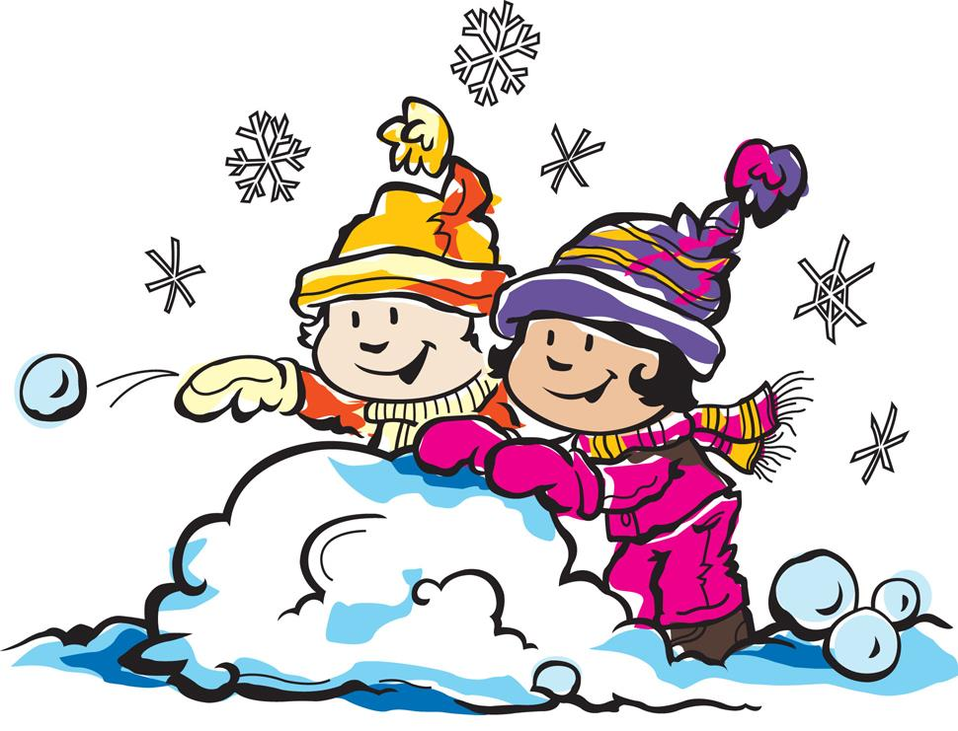

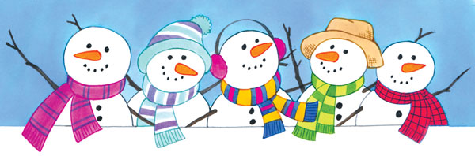
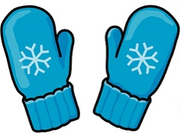
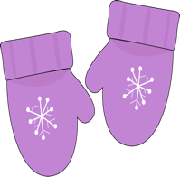
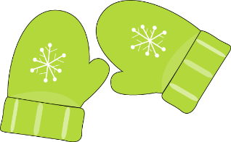
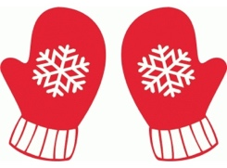
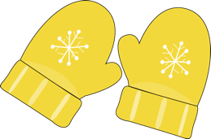
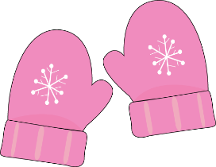

5 Little Snowmen
5 little snowmen jumping in the snow,
1 fell off and bumped his toe.
Mama phoned the doctor and the doctor said,
“No more snowmen jumping in the snow.”

4 little snowmen jumping in the snow...
3 little snowmen jumping in the snow...
2 little snowmen jumping in the snow...

1 little snowman jumping in the snow...
He fell off and bumped his toe.
Mama phoned the doctor and the doctor said,
“Put those snowmen right in bed.”

