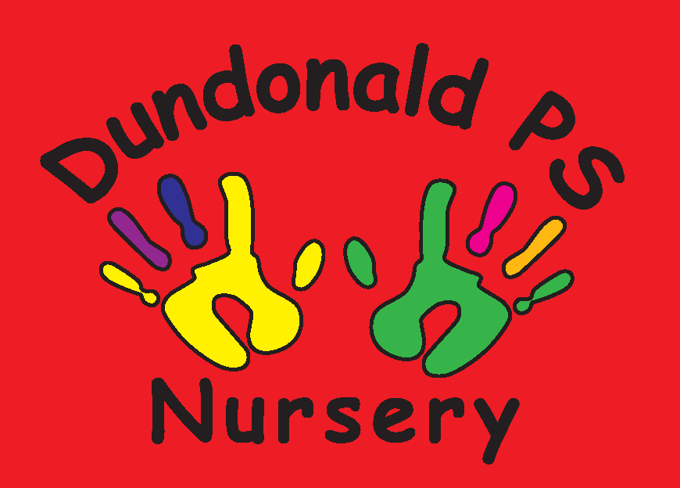
Dundonald Nursery December Songs & Rhymes

Clap Hands for Christmas
Clap hands for Christmas (clap hands 3 times),
Clap hands for Christmas (clap hands 3 times).
Fingers make a Christmas tree,
Make it stand as tall as me,
Lots of twinkling lights I see.
Clap hands for Christmas time (clap hands 2 times).

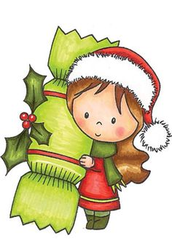
5 Christmas Crackers
5 Christmas Crackers in our hand.
Choose one, pull one,
It goes BANG!

4 Christmas Crackers in our hand...
3 Christmas Crackers in our hand...
2 Christmas Crackers in our hand...

1 Christmas Cracker in our hand...
Choose one, pull one,
It goes BANG!

Here we go Round the Christmas Tree

This is the way we make a star, make a star, make a star.
This is the way we make a star at Christmas time in the morning.

(Chorus)
Here we go round the Christmas tree, the Christmas tree, the Christmas tree.
Here we go round the Christmas tree at Christmas time in the morning.

This is the way the crackers bang, crackers bang, crackers bang.
This is the way the crackers bang at Christmas time in the morning.

This is the way we wrap the presents...
This is the way we hang up the stockings...
This is the way we jump for joy...




I’m a Little Snowman
I’m a little snowman, look at me.
These are my buttons, 1 2 3.
These are my eyes and this is my nose.
I wear a hat and scarf. Brrr...it’s cold!


S-A-N-T-A
Red hat, white beard, twinkle in his eye.
Santa is his name-o.
S-A-N-T-A
S-A-N-T-A
S-A-N-T-A
And Santa is his name-o.

Away in a Manger
Away in a manger no crib for a bed,
The little Lord Jesus laid down His sweet head.
The stars in the bright sky looked down where He lay,
The little Lord Jesus asleep in the hay.

The cattle are lowing, the baby awakes,
But little Lord Jesus no crying He makes.
I love You Lord Jesus; look down from the sky,
And stay by my side until morning is nigh.

Be near me Lord Jesus, I ask you to stay,
Close by me for ever, and love me, I pray.
Bless all the dear children in your tender care,
And fit us for heaven, to live with you there.


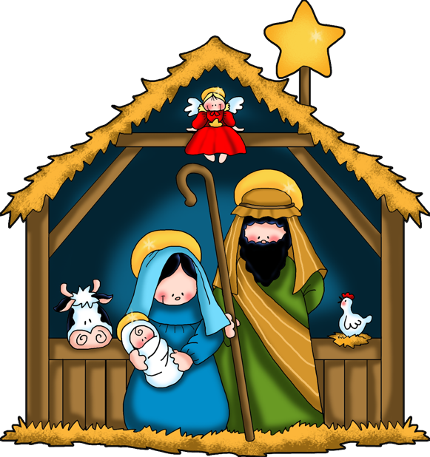
We will Rock You
Little Jesus, sweetly sleep, do not stir,
We will lend a coat of fur.
We will rock you, rock you, rock you,
We will rock you, rock you, rock you.
See the fur to keep you warm,
Snugly round your tiny form.

Mary’s little baby, sleep, sweetly sleep,
Sleep in comfort, slumber deep.
We will rock you, rock you, rock you,
We will rock you, rock you, rock you.
We will serve you all we can,
Darling, darling little man.

