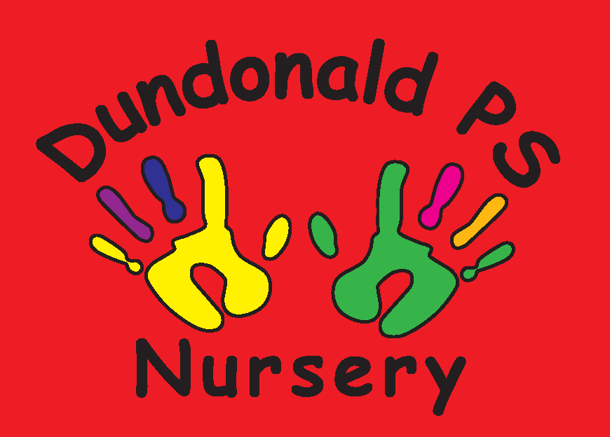
Dundonald Nursery September Songs & Rhymes
Humpty Dumpty
Humpty Dumpty sat on a wall
Humpty Dumpty had a great fall
All the Kings horses and all the Kings men
Couldn’t put Humpty together again
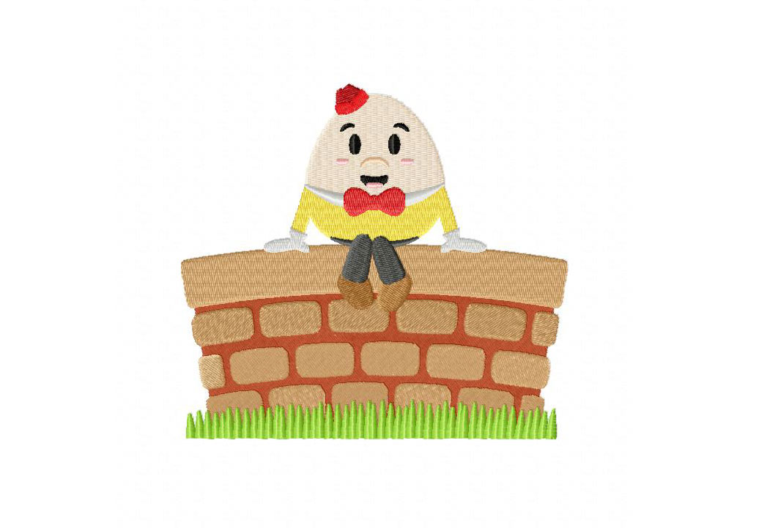


Wind the Bobbin Up
Wind the bobbin up Wind the bobbin up Pull, Pull, clap, clap clap (repeat)
Point to the ceiling, Point to the floor Point to the window, Point to the door Clap your hands together, 1,2,3 Put your hands upon your knees.

2 Little Dickie Birds
Two little Dickie Birds sitting on the wall One called Peter, one called Paul Fly away Peter, Fly away Paul Come back Peter, Come back Paul
(A fun action rhyme to encourage your child to learn their friends names-Try replacing Peter & Paul with your child’s name and someone they know in nursery – how many names can they recall?)



